Best Practices from Departments

SKR & SKR Govt. College for Women (A) YSR KADAPA
NAAC Re Accredited Institution at ‘B’ Level
(Affiliated to Yogi Vemana University)

BEST PRACTICES BY ALL THE DEPARTMENTS

SKR & SKR Govt. College for Women (A) YSR KADAPA
NAAC Re Accredited Institution at ‘B’ Level
(Affiliated to Yogi Vemana University)
Department of Botany

Student Counselling for various adjustmental problems.
 Objectives of the Practice
1. Understanding self
2. Coping with difficult situations
3. Acquiring positive self regard and sense of optimision about one‟s own ability.
4. Effective solutions to personal and interpersonal problems.

 The Context
• In the present scenario because of Globalization we are getting so many opportunities like getting jobs, getting technological advancement and flow of information and so on.
• At the same time we are getting so many problems like family disputes, language problems,adjustmentalproblems , loss of beloved ones, lack of Emotional adjustment, over usage of technology, adopting Foreign culture like pub culture and so on.
• For them in counseling Social stigma plays the challenging role in counseling. So many members do not come out side to express them feelings.
• So, it is difficult to give individual counselling. To identify the cultural differences also a challenge. Time factor is another challenge for teacher counselor.
• Students may avoid attending counseling session during class timings. Some members they do not have any awareness regarding counselling.
 The Practice and Uniqueness
• In the present scenario for gaining comfortable life, people are dumping so much of stress in their brains.
• They are facing so many problems like inferiority complex, suicidal tendency and in the adolescent period they may fall in so many attractions and getting pain.

For this to know of their strengths and weakness and to lead to peaceful life in the society.
• In my Institutions we don‟t have any Psychology departments and counsellors.
• But in our Govt. College for women we have the Psychology dept. and give the group counselling regarding of various issues like adjustmental problems, Inferiority complex issues, suicidal tendency and so on.

 Evidence of Success
• Through Academic counseling students got the Improvement. We can check their output by Evaluation.
• We can identify their behavioural changes / adjustment in the society after counseling by taking feedback.
• So, we can know the adjustment of thee Individuals. So, there is need for counselling.

 Problems Encountered and Resources Required
• There are so many Therapies in counseling regarding the density of the problem. So, in counseling session to follow different approaches is difficult in the college. More & more tests to be needed to identify problem.
• Assistance is needed to record the client‟s progress and to maintain record. There must be need for counselling room with sound proof for getting privacy.

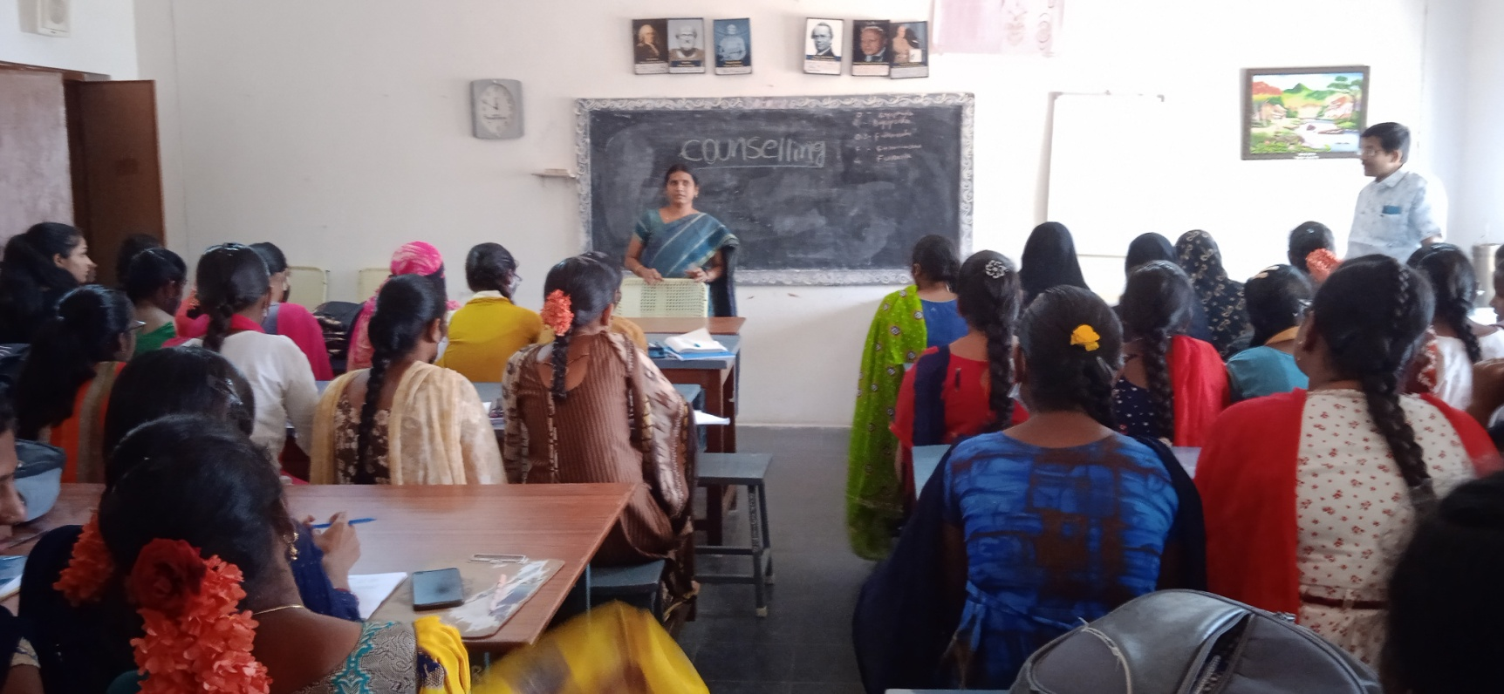

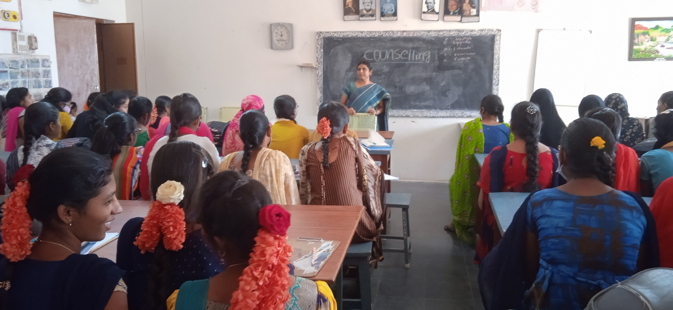
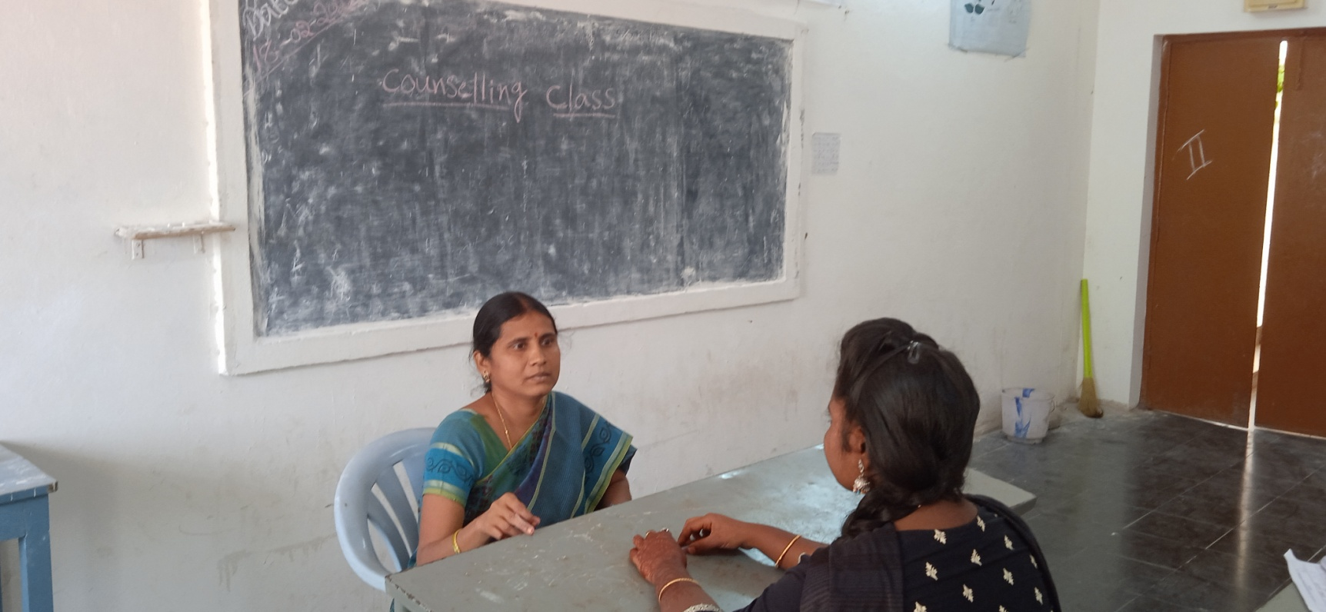

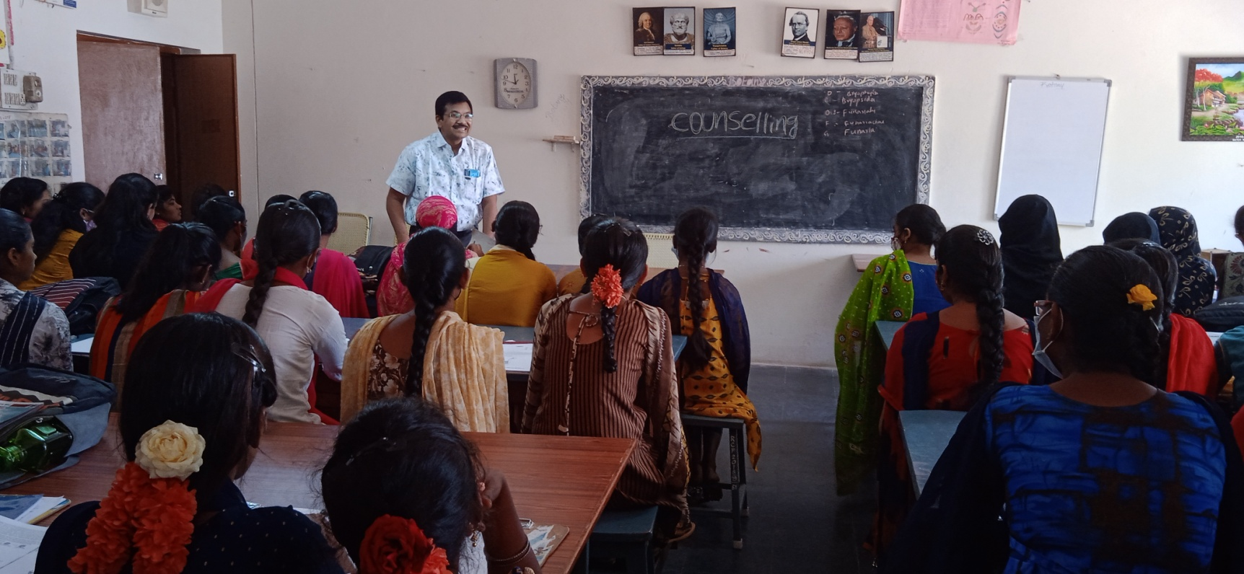
Presentation of Guest Lecture by Dr.A.Madhusudhana reddy,Associate Professor,YVU.Kadapa

SKR & SKR Govt. College for Women (A), Kadapa.
Department of Zoology
Guest Lectures- DETAILS
2020-2021 | 03-02-2021 | Dr. C. Narasimharao, Lecturer in Zoology, Govt. College for men(A), Kadapa | Fermentation & Types | All III B.Sc Students  Students attended-95
2020-2021 | 05-02-2021 | Dr. Sachidevi.P, Lecturer in Zoology, Govt. College for men(A), Kadapa | Hybridoma technology & Stem cells | All III B.Sc Students  Students attended-95

SKR & SKR Govt. College for Women (A), Kadapa.
Department of Chemistry
Guest Lectures- DETAILS
Academic Year | Date | Name of the Guest lecturer | Topic of the Lecture | Class
2020-2021 | 23-01-2020 | Dr.B.Ramachandra, Lecturer in Chemistry, GCMA, Kadapa | IR Spectroscopy | II B.Sc Students-75
2020-2021 | 27-10-2021 | Sri.A.Viswanatha Reddy, Rtd DFC, IPM, Vijayawada | Food Adulteration | First year Degree students-150
2021-2022 | 21-12-2021 | Dr.S.Susmitha, Asst.Professor, Dept.of Envi.Science, YVU, Kadapa | Environmental Laws and Audit | Second year Degree Students-120

SKR & SKR Govt. College for Women (A), Kadapa.
Department of Chemistry
Guest Lectures- DETAILS
Academic Year | Date | Name of the Guest lecturer | Topic of the Lecture | Class
2020-2021 | 23-01-2020 | Dr.B.Ramachandra, Lecturer in Chemistry, GCMA, Kadapa | IR Spectroscopy | II B.Sc Students-75
2020-2021 | 27-10-2021 | Sri.A.Viswanatha Reddy, Rtd DFC, IPM, Vijayawada | Food Adulteration | First year Degree students-150
2021-2022 | 21-12-2021 | Dr.S.Susmitha, Asst.Professor, Dept.of Envi.Science, YVU, Kadapa | Environmental Laws and Audit | Second year Degree Students-120

SKR & SKR Govt. College for Women (A), Kadapa.
Department of Chemistry
Guest Lectures- DETAILS
Academic Year | Date | Name of the Guest lecturer | Topic of the Lecture | Class
2020-2021 | 23-01-2020 | Dr.B.Ramachandra, Lecturer in Chemistry, GCMA, Kadapa | IR Spectroscopy | II B.Sc Students-75
2020-2021 | 27-10-2021 | Sri.A.Viswanatha Reddy, Rtd DFC, IPM, Vijayawada | Food Adulteration | First year Degree students-150
2021-2022 | 21-12-2021 | Dr.S.Susmitha, Asst.Professor, Dept.of Envi.Science, YVU, Kadapa | Environmental Laws and Audit | Second year Degree Students-120

DEPARTMENT OF MATHEMATICS
2021-2022

SKR & SKR GOVT. COLLEGE FOR WOMEN (A), KADAPA
NAAC Reaccredited at ‘B’ level

FIELD VISIT REPORT

- Name of the department: Mathematics

- Name of the faculty organised: Dr P. Gurivi Reddy,
Kum K. Shalini
Smt K. Sunitha

- Title of the Activity: Field visit

- Date : 07.01.2022

- Number of faculty participated: 05

- Number of students participated: 70

BRIEF REPORT

Department of Mathematics went field trip to Talakona and Regional Science Centre, Tirupati on 07.01.2022. Talakona waterfall is situated near Bakrapeta in Nallamala Hill range and 40 km away from Tirupati. The height of the waterfall here is 270 feet. Eswara temple is situated near the waterfalls. Talakona is the highest waterfall in Andhra Pradesh state. It is a resort well endowed with waterfalls, dense forest and wild life. The forest host certain rare and endangered species of animals. Staff and students at an uphill riverlet a stream of running water that’s so as fresh and soothing. Students recreated and enjoyed a lot.
Students visited Regional Science Centre, Tirupati. The centre is called as Science temple because of its exclusive collection. The Regional science centre, Tirupati has 6 permanent exhibition gallaries namely funscience, our senses, popular science, illusion and emerging technology and our universe. Mathematical concepts like parabola, Hyperbola, Conics, Rings, Ellipse, Value of Pi, Infinity well, Cubism etc. Students gain knowledge by visiting these places.
Talakona
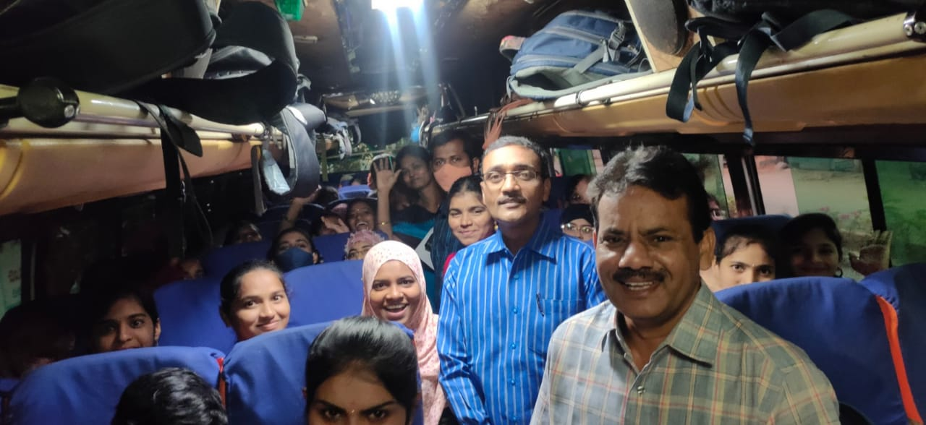
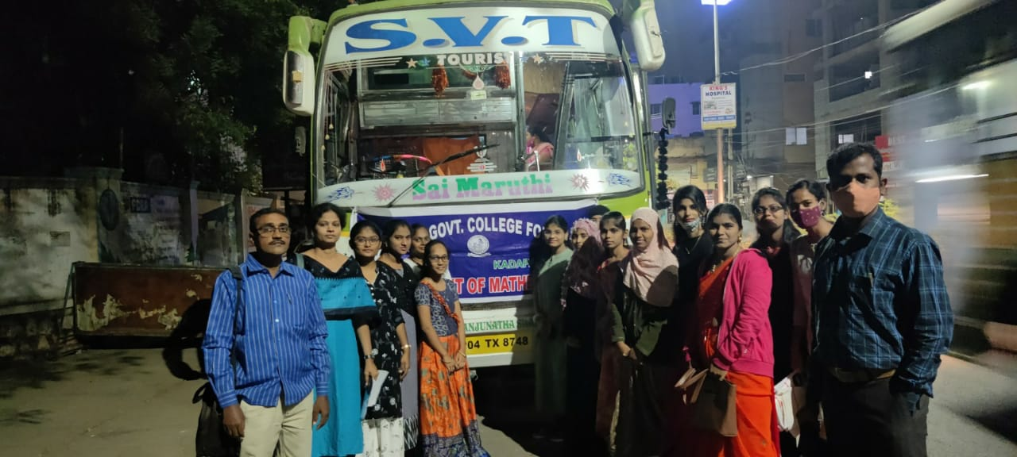

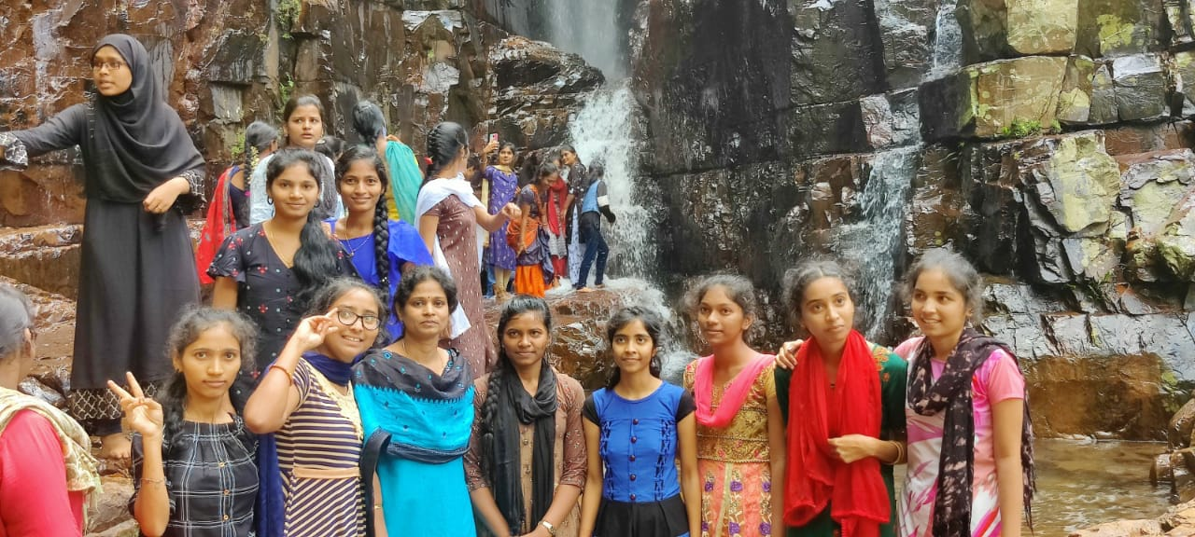

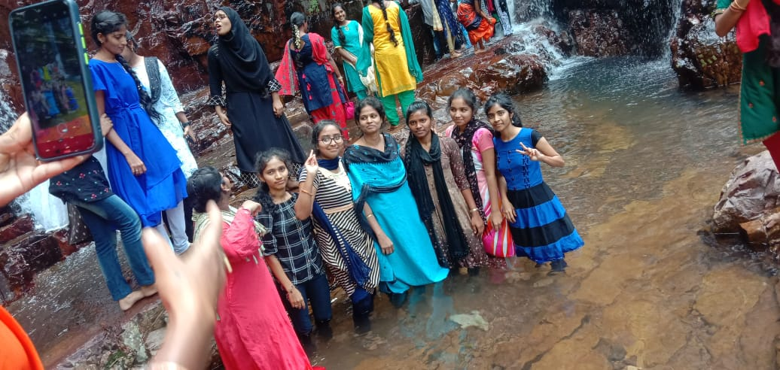

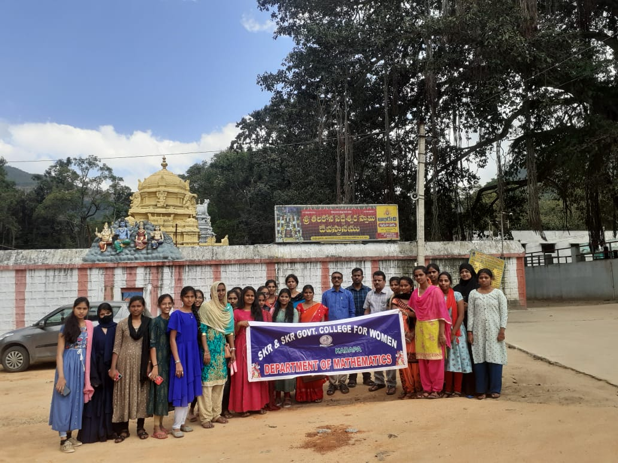

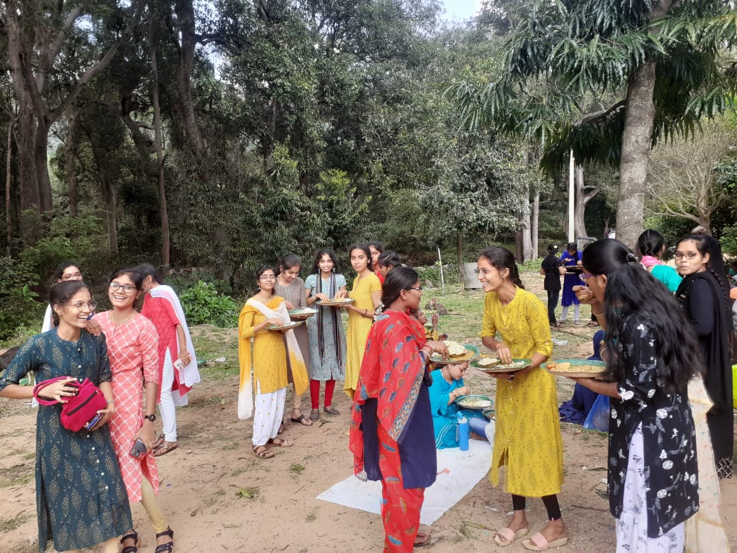

regional science centre, Tirupati

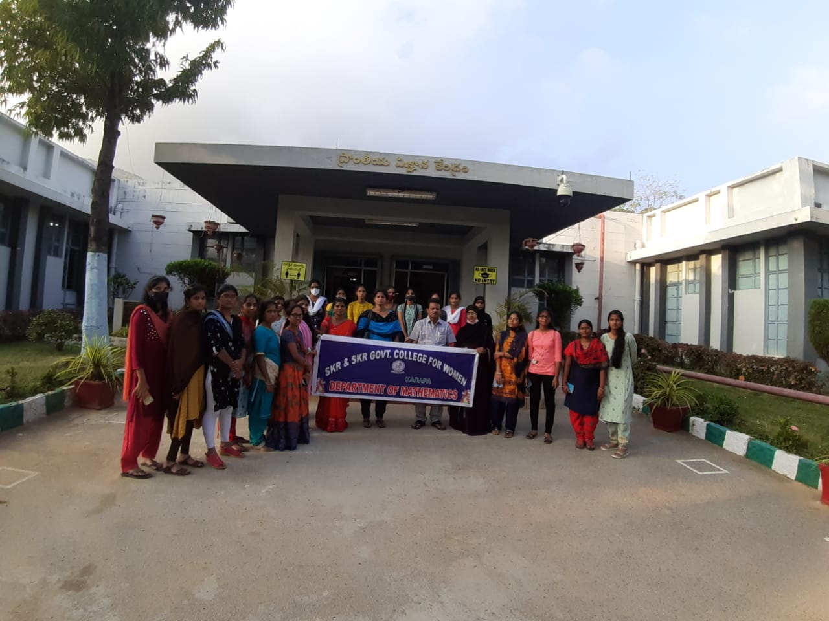

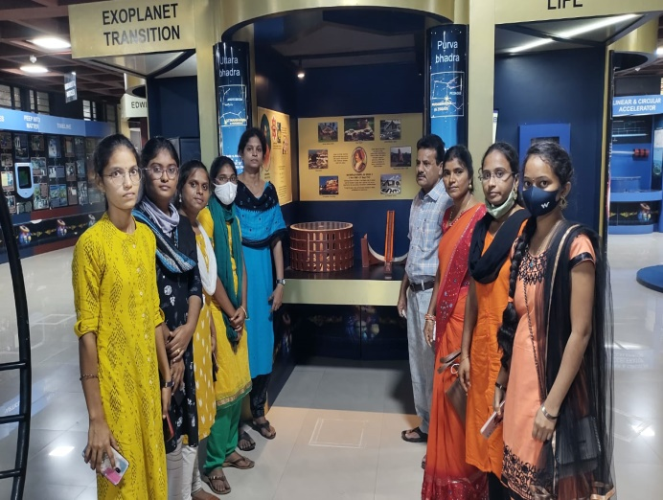

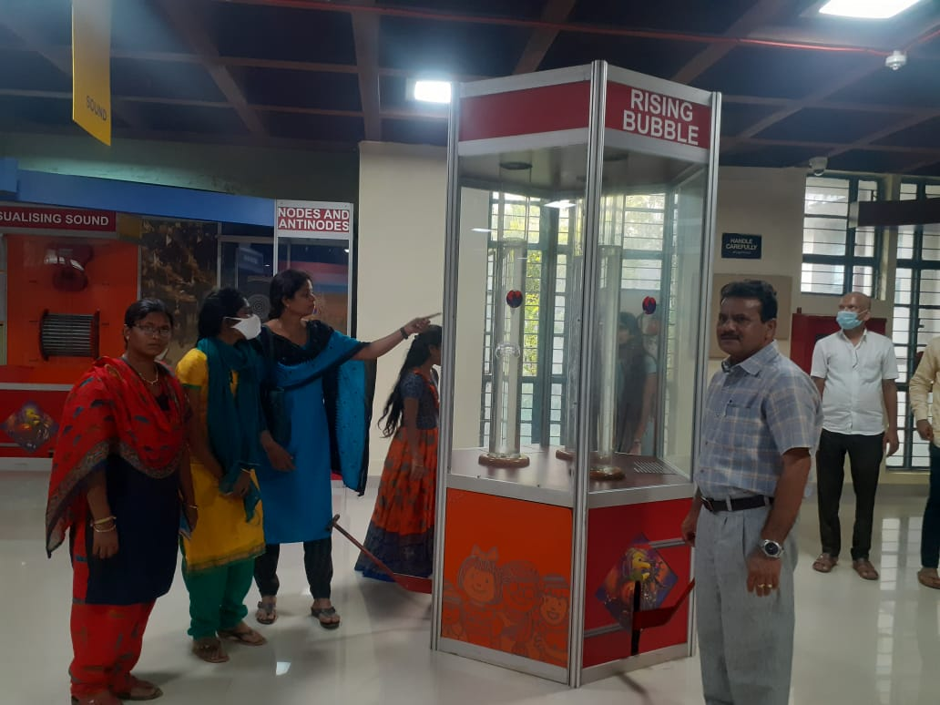

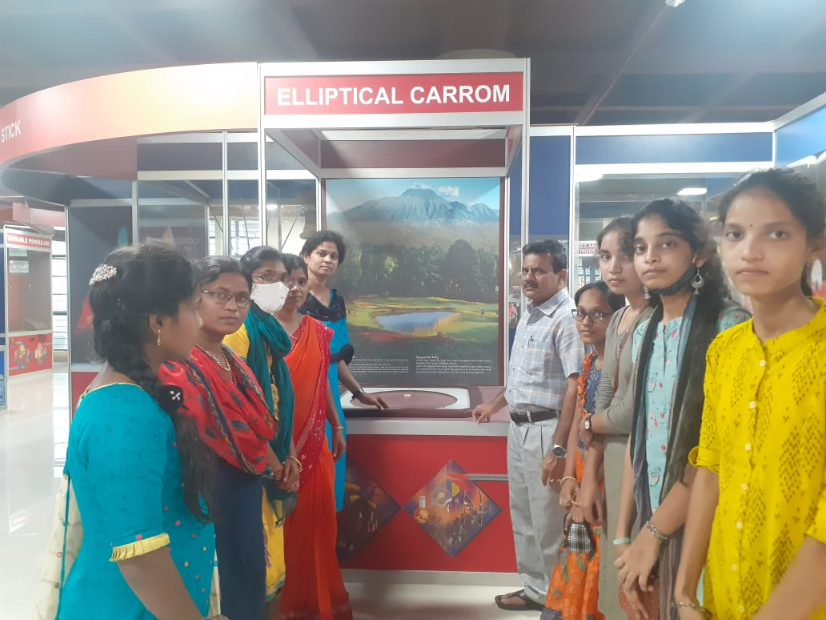
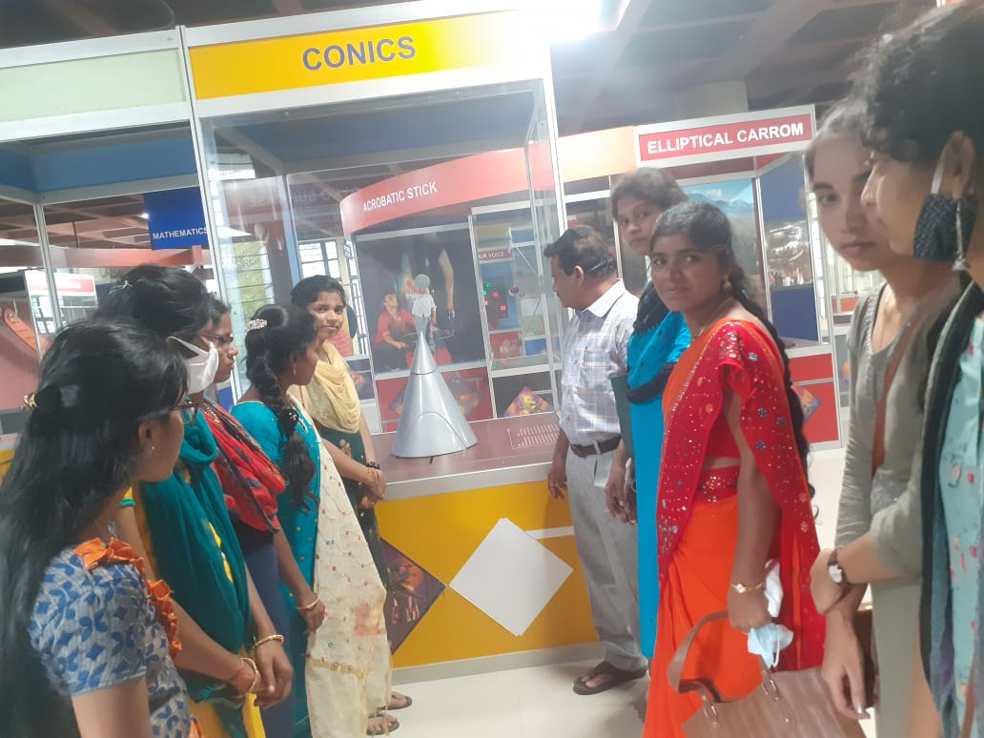
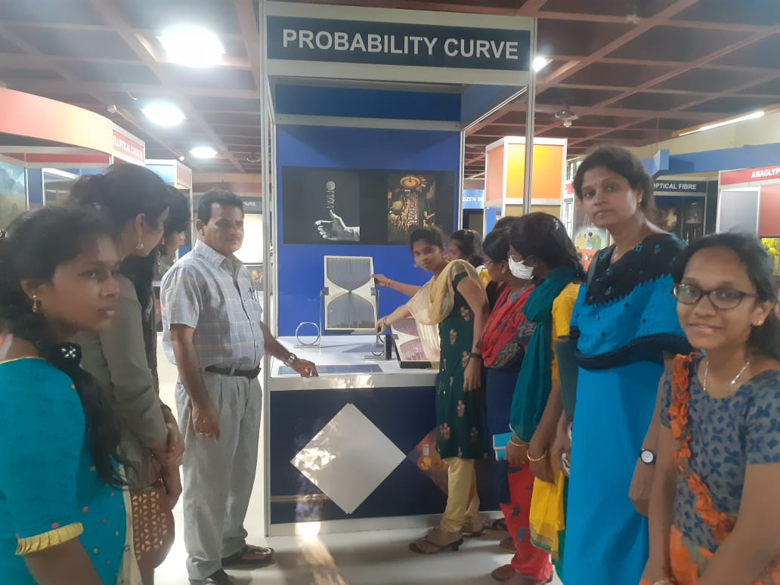
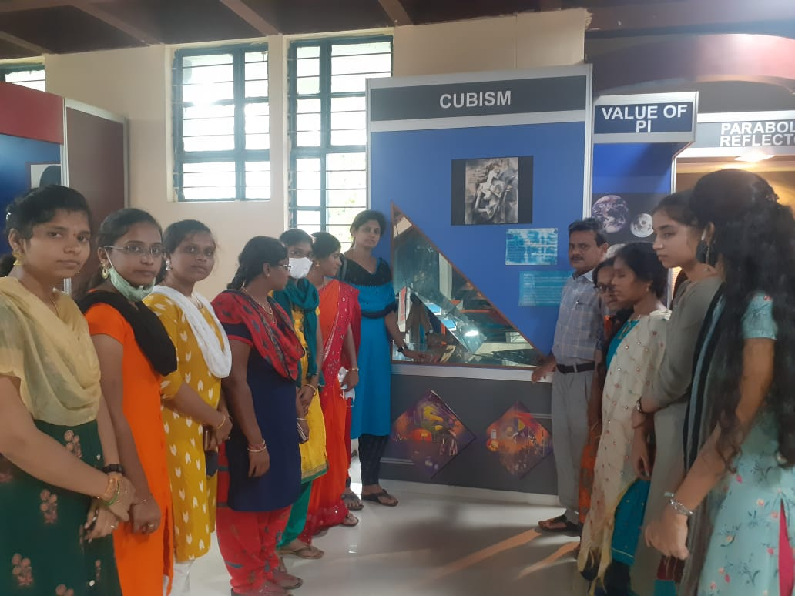
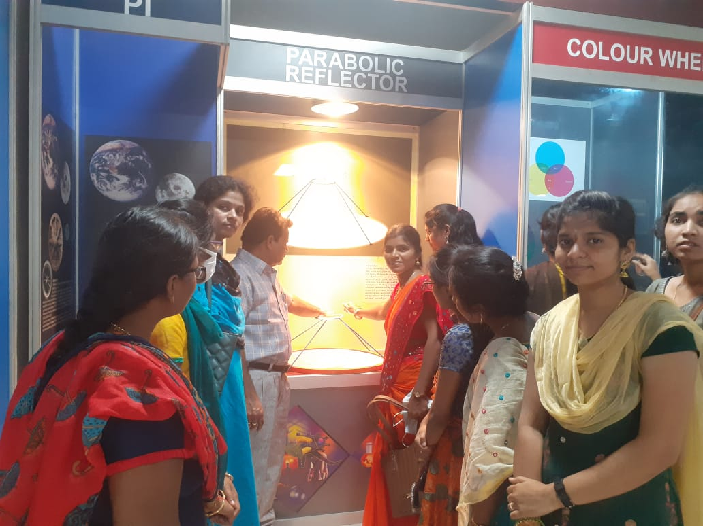

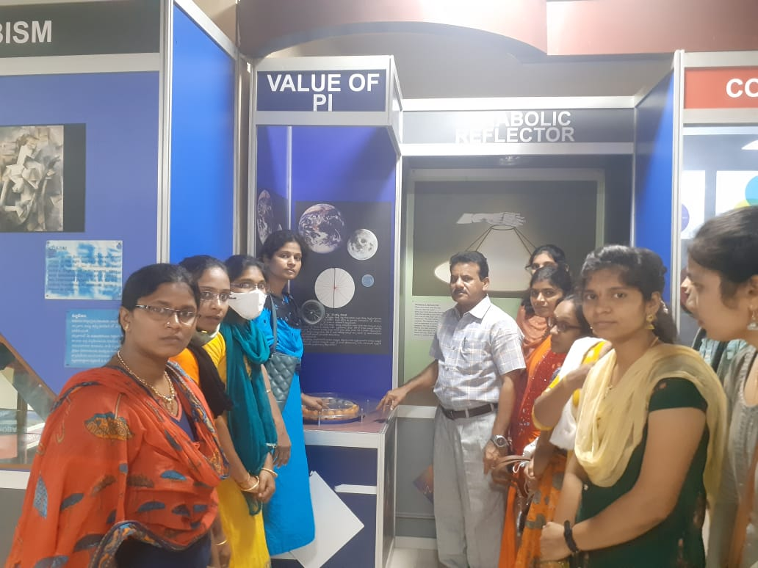
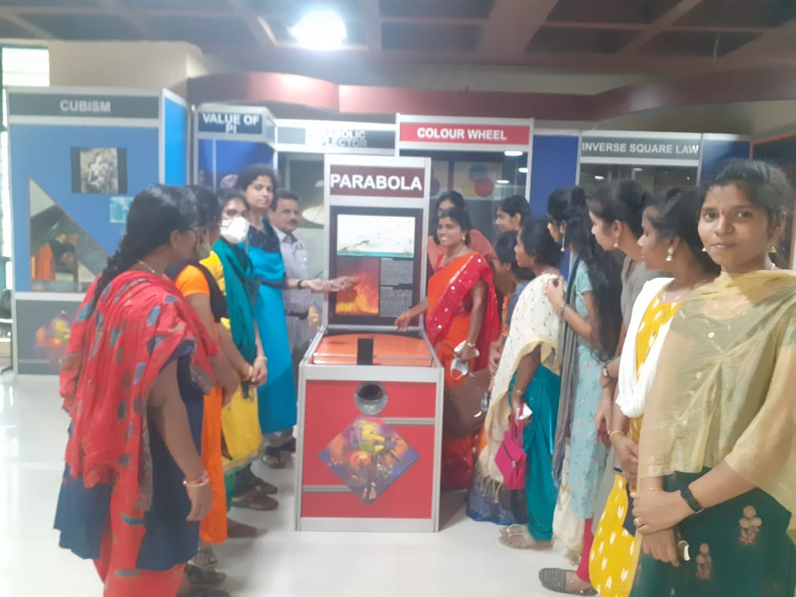

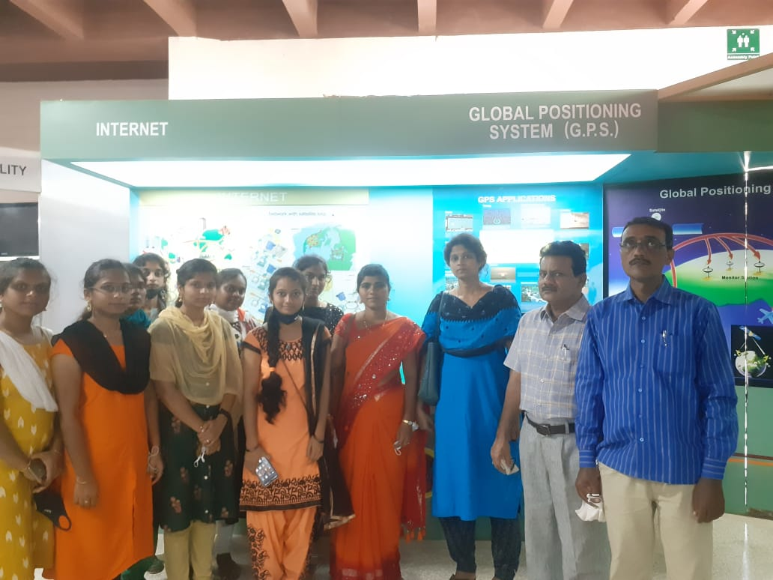
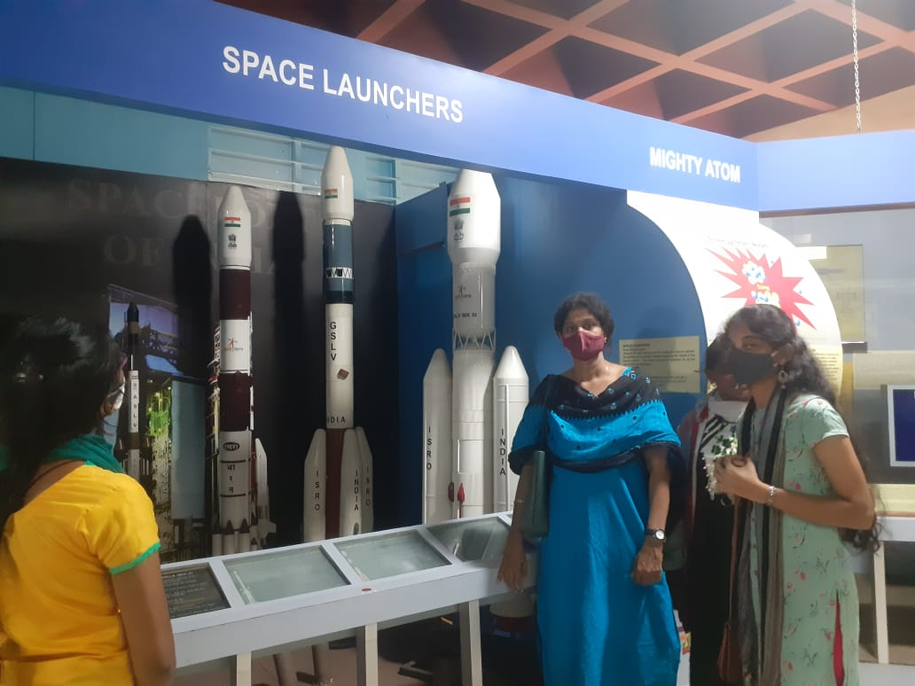
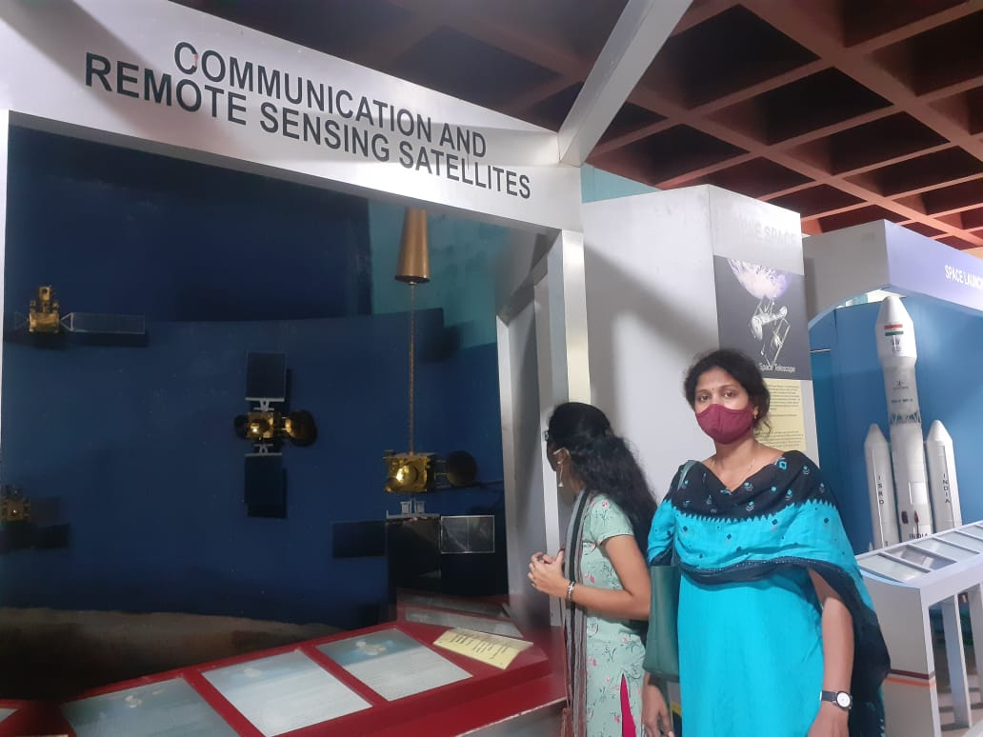

SKR & SKR GOVT.COLLEGE FOR WOMEN’S (AUTONOMOUS), KADAPA
DEPARTMENT OF BOTANY
NAAC Re Accredited with B Level

Report on Field visit and Instrumentation lab, YV University, Kadapa on20.12.21

1. Name of the Department : Botany
2. Name of the Faculty Organized : B.Yugavani
Dr. P.Subramanyam
Y.Nagarathnamma
3. Title of the activity : FIELD VISIT
4. Date : 20.2.2021
5. Number of faculty participated : 03
8. Number of students involved/Participated : 70 III EM & TM
9. A Brief Report ( with pics and feedback) :
As we know that, botanical gardens are basically intended for exhibiting various plant specious for aesthetic pleasure and out of conservational concerns. The plant collections serve the purpose of display as livelihood, education, research, conservation, environmental education.
Botanical Garden at YVU is spread nearly in 20 Acres of land & it was established in 2008. The garden is beautiful and well maintained. It contains an impressive collection of various plants live ornamental, Medicinal plants and climbers of rare and endangered species also. The Garden with more than 700 varieties of Medicinal and Endangered plants are maintain in the Botanical Garden. Nearly 75 students along with faculty visited the garden on 20.12.2021.
Dr. A. Madhu Sudhan Reddy, Assistant Professor of Botany & NSS Coordinator distributed some plants on the occasion of Azadika Amuthmahatsav for this event Dr. Vijaya Raghava Prasad Registrar Y.V University and Dr. Chandramati Sankar Principal involved.
Assistant Professor Dr. A. Madhu Sudhan Reddy garu and his scholars Mr.Prasad and Nagendra garu explained the Morphological, Taxonomical and economic importance of each and every species growing in the garden. The species are all labeled with Botanical names and common name, family etc., So that the students can identified easily.
This botanical garden is treasure of ex situ conservation of endangered and endemic plant species. So the Botanical garden is nearly centre for Research purpose in the field of Botany,
LEARNING OUTCOMES OF FIELD TRIP
1. Learn about important morphological characters of plants for taxonomic purposes.
2. Learn to make plant collections for a wide range of future uses.
3. Collect and prepare botanical specimens [for herbarium with the help of field note book] for scientific purposes.
4. Learn Ex situ conservation strategies in botanical garden.
5. Independently prepare and develop a reference collection with notes about diagnostic characters that serves as a practical and to plant.

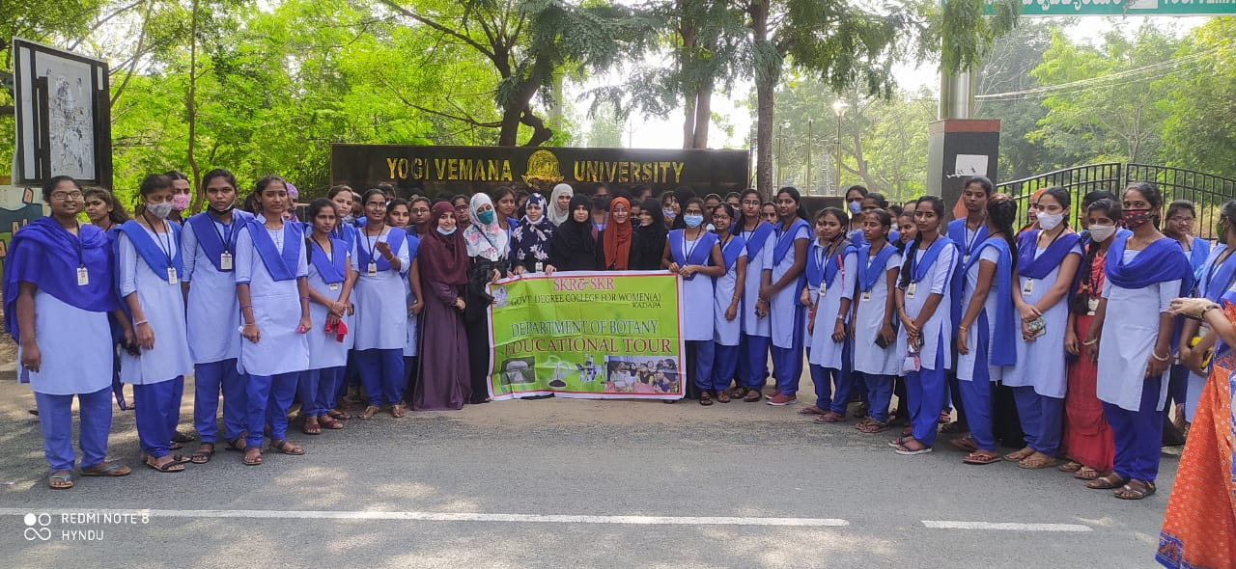

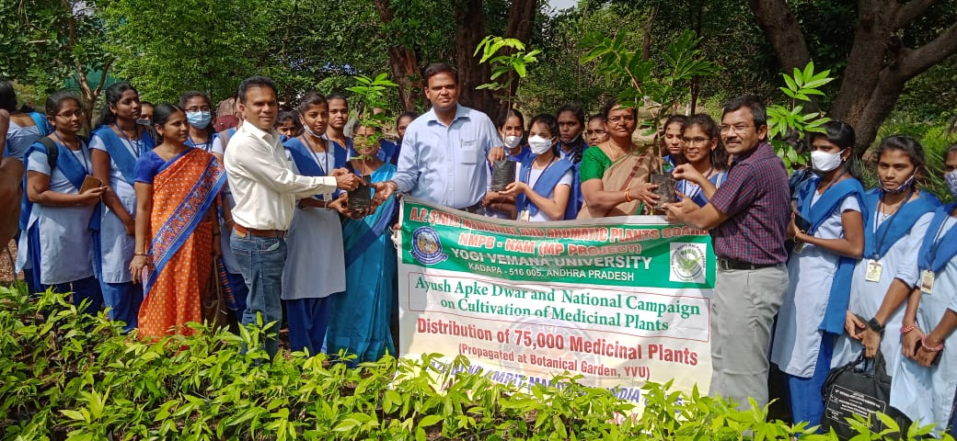

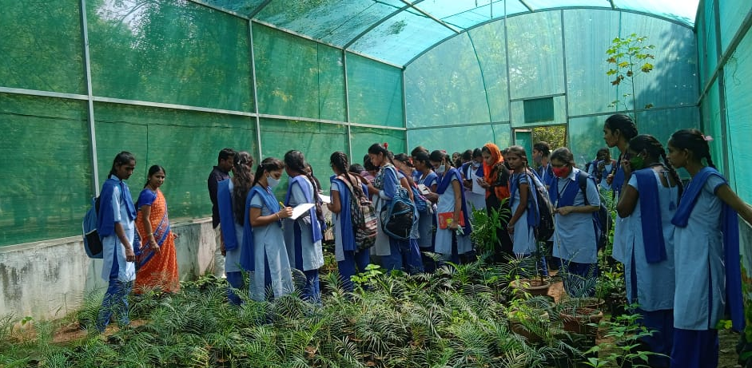
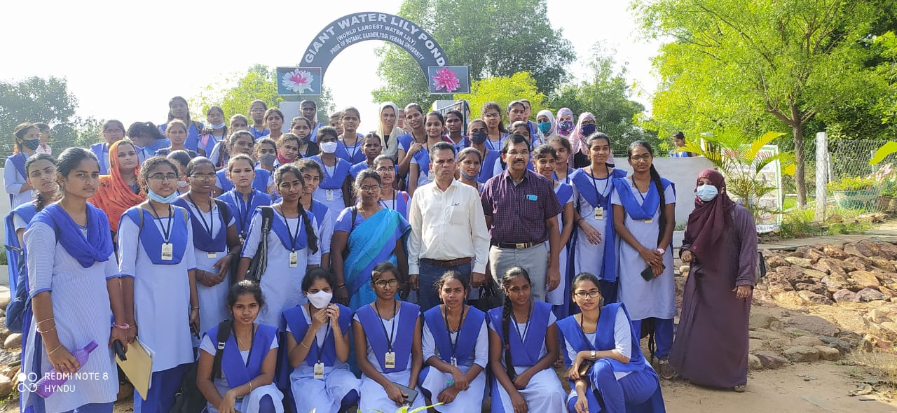
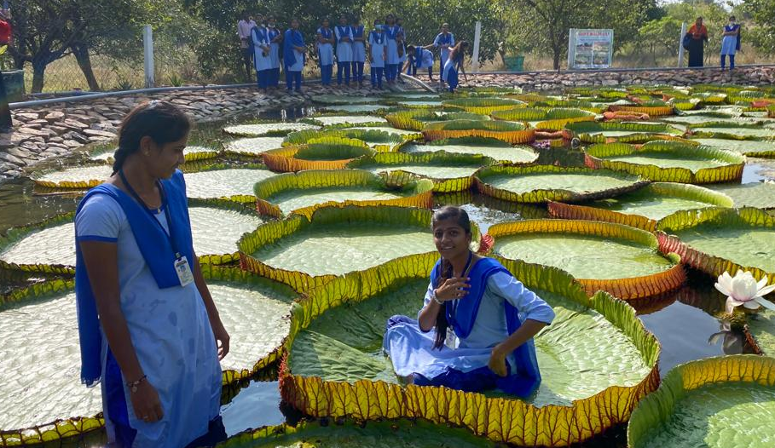
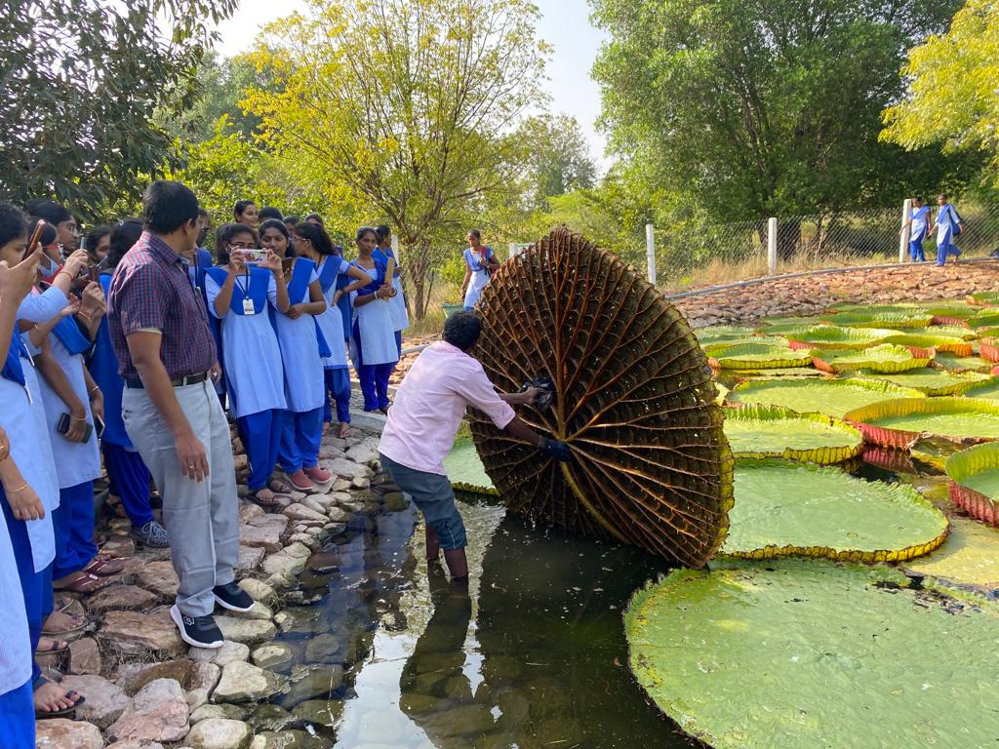
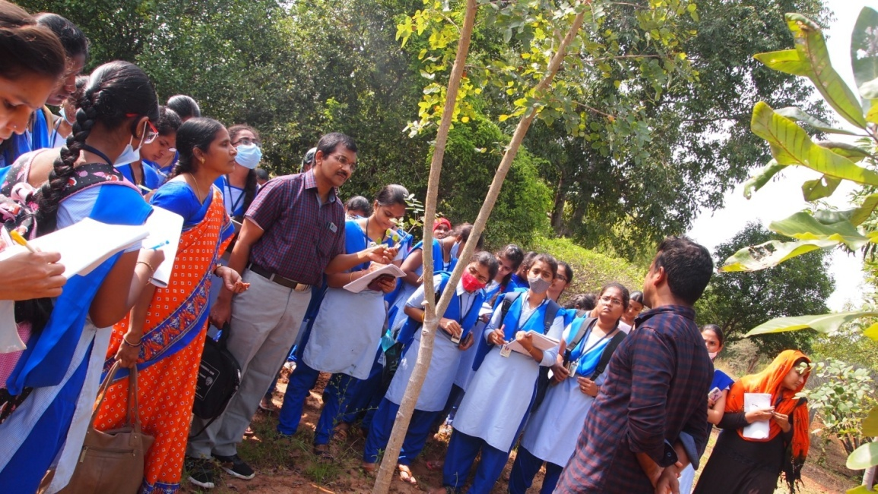
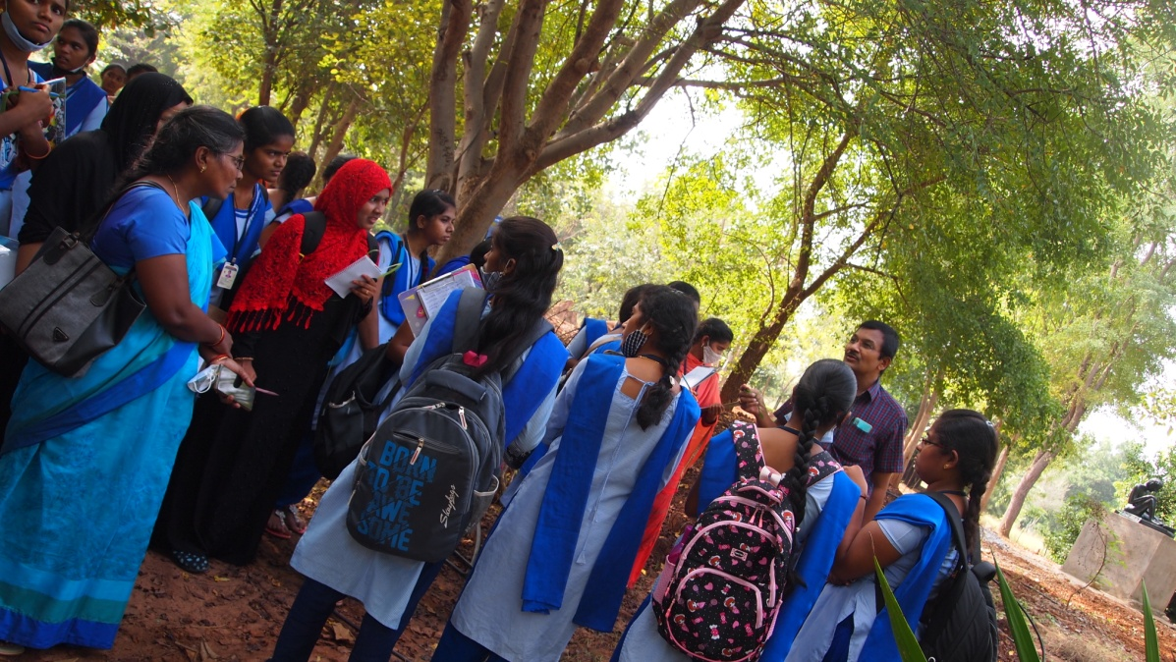
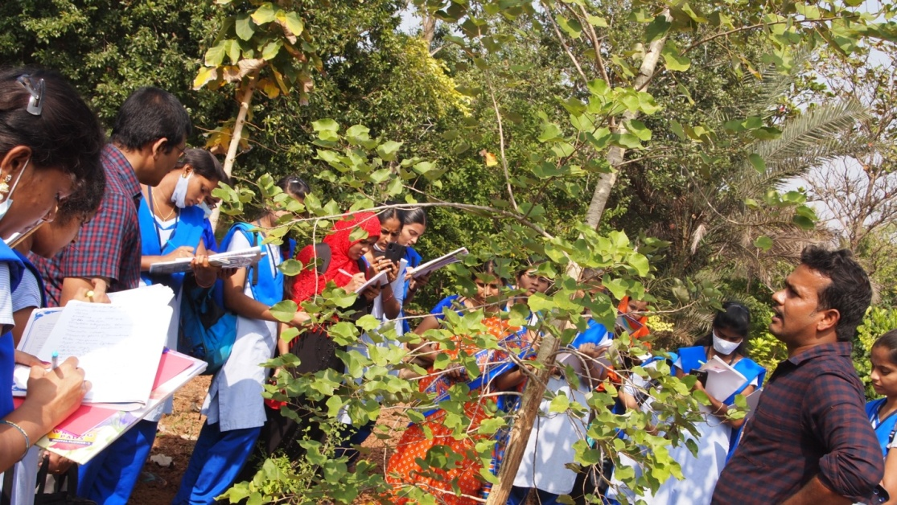

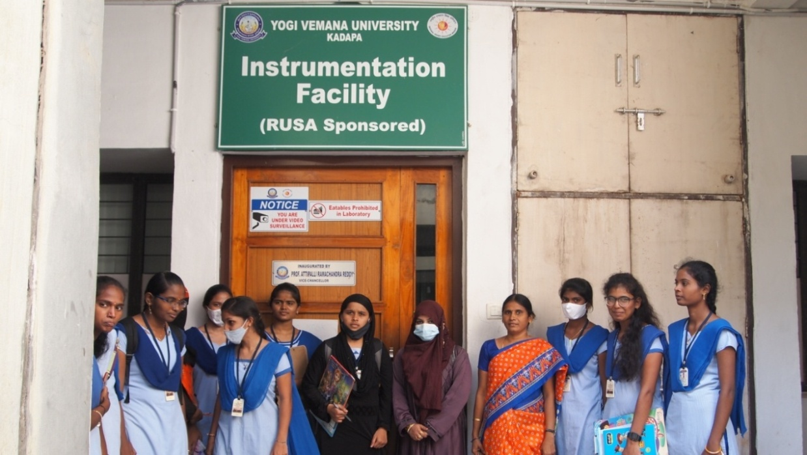

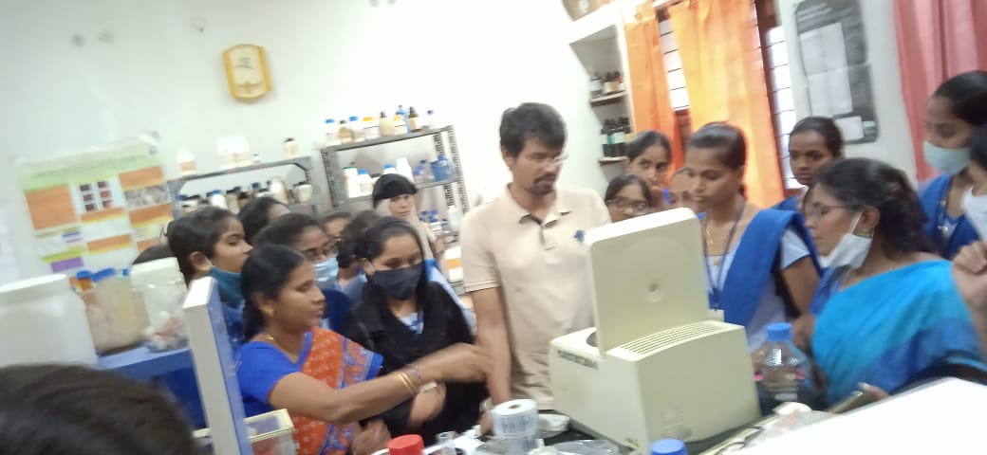

DEPARTMENT OF ENGLISH
2021 - 2022

QUIZ PROGRAMME –SEM 3 –SECOND MSCS




SKR & SKR Govt. College for Women (AUTONOMOUS) KADAPA
NAAC Re Accredited Institution at ‘B’ Level
(Affiliated to Yogi Vemana University)
SKR & SKR Govt. College for Women (AUTONOMOUS) KADAPA
NAAC Re Accredited Institution at ‘B’ Level
(Affiliated to Yogi Vemana University)

Department of ENGLISH

Quiz Programme

S.NO | GROUP-A | GROUP-B
1 | K.CHANDANA | A.NAGARATHNA
2 | S.KHADER BEE | S.ASIFA
3 | S.NOOHIA | B.BHAGYA SREE

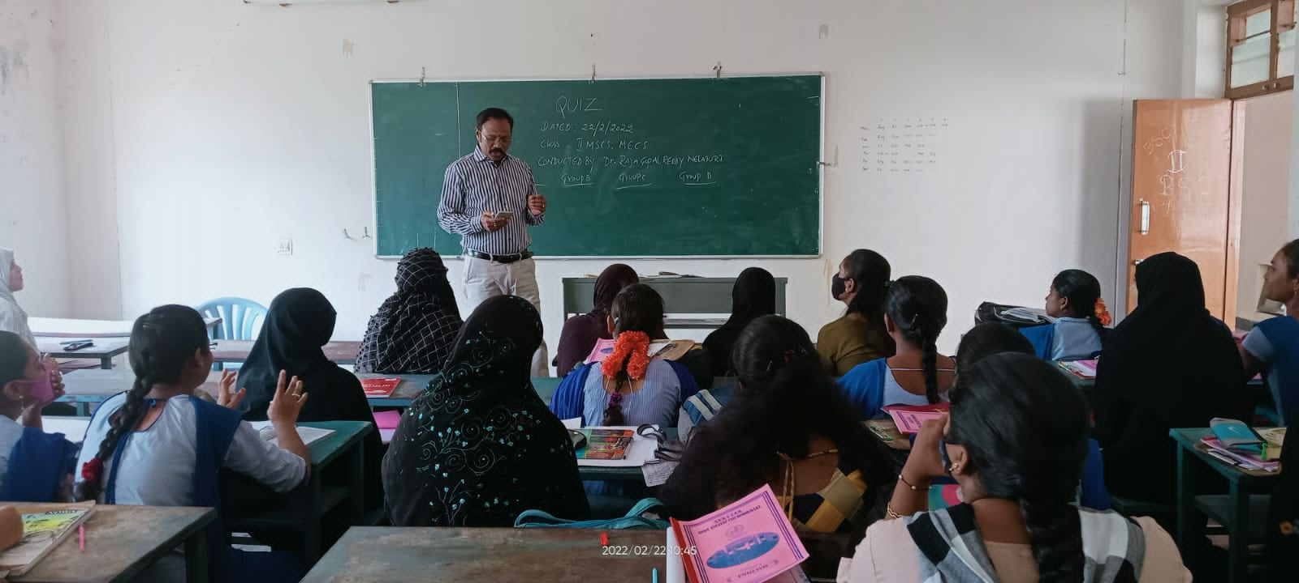

SKR & SKR Govt. College for Women (A), Kadapa
Department of Chemistry
BEST PRACTICE: RAIN WATER HARVESTING
2020-2021
Objective of the Practice:
- To provide practical experience to the students of chemistry by collecting rain water.
- Rainwater harvesting (RWH) is the collection and storage of rain, rather than allowing it to run off. Rainwater is collected from a roof-like surface and redirected to a tank.
- Rain water is used instead of distilled water in the lab.
- distilled water is the purest type of water
- The distillation process is very effective at removing potentially harmful contaminants, but it also removes the natural minerals and electrolytes found in water.
Context of the Practice:
- As the distillation unit/deionizer in the department stopped working to prepare the distilled water, Chemistry department has relied on rain water since it is the purest form of water.
- Rain water is collected during rainy season in the drums and water is utilized for all the practical work done in the chemistry laboratories.
Practice:
- The department of chemistry started harvesting rain water since 2010 onwards.
- Collected rain water is filtered and stored in the chemistry laboratory.
- The water is then utilized for the practical work for the entire academic year.
Evidences:
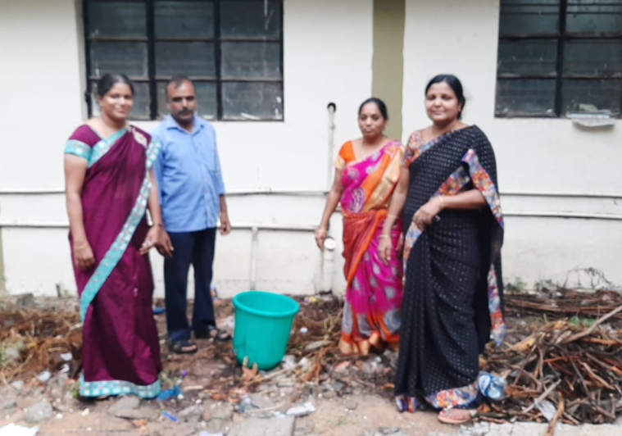
Collection
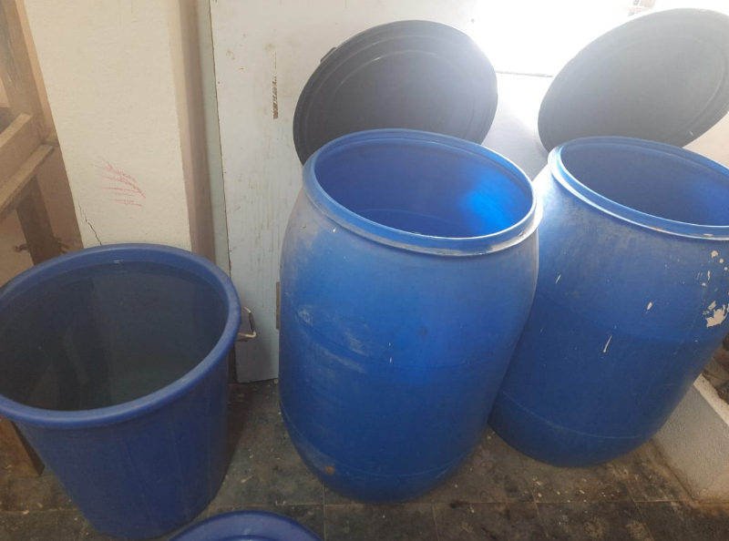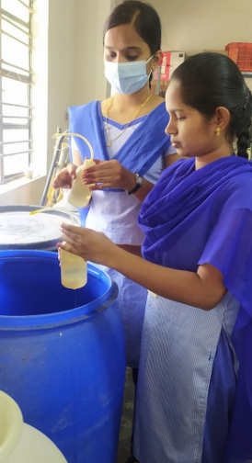
Storage Students collecting water
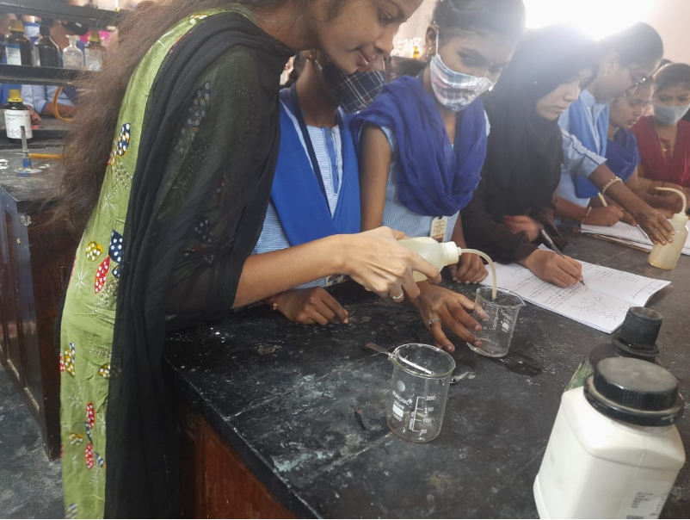
Rain water utilizing during practical work

SKR & SKR Govt. College for Women (A) YSR KADAPA
NAAC Re Accredited Institution at ‘B’ Level
(Affiliated to Yogi Vemana University)
DEPARTMENT OF ECONOMICS
2020 - 2021
Field Trip
Sem-1, sem-3 & sem-5

ACTIVITY REPORT

1. Name of the Department : ECONOMICS

2. Name of the Faculty Organised :Dr. G.Vijaya Lakshmi Devi,

:T.Srinivasulu Reddy
: Dr.M.Gurumohan Reddy
3. Title of the activity : FIELD VISIT

4. Date and time : 17-12-2021; 5.00 am to 9.30pm

5. Resource persons : Prakrithi Vanam Prasad garu
6. Number of faculty participated : 03

7. Number of students involved/Participated : 60

8. A Brief Report (with pics and feedback) :

Today the Department of Economics organised a Field Visit programme. In this programme the department visited the Prakruthi Vanam organic food products Industry at Madanapalli. In this programme sixty students and lectures were participated. The purpose of this visit is to understand the importance of organic food products. Particular attention was given to know the relevant information that is how to useful of organic products in health point of view. In this visit the students and staff were interacted with Prakrithi Vanam prasad garu regarding how the products have been manufacturing in that industry and which fertilizers are using to produce the products and how the useful to health to improve the immunity. Prakruti Products specializes in the manufacture of standardized herbal extracts, phytochemicals, organic ingredients and nutraceutical ingredients for leading dietary / food supplement manufacturers around the world. Founded in 1998, Prakruti Products is the largest manufacturer of Garcinia cambogia extract Globally.

Horsely hills visit

ప్రకృతివనం (Prakruthivanam) Organic Store

Gurram konda Fort visit

Millet processing unit

PLANTATION PROGRAMME
Tree plantation programme at skr &skr Government degree college for women )A) kadapa is organized by the faculty of
Botany Department. students of our College understood the importance of Tree Planation Programme for the prevention of air pollution in
nature as the trees help to reduce Carbon index, air pollution, Green House Gases and so many hazards in nature.

- Name of the department: BOTANY
- Name of the faculty organised:
- Title of the Activity: PLANTATION DATE: 27.11.2021

- Number of faculty participated: 03

- Number of students participated: 20

1. Objective of the Practice :
. to reduce Carbon index, air pollution, Green House Gases and so many hazards in nature
To realize the purpose or usefulness of plants/trees.
2. Need Addressed and the Context:

To have the awareness of richness of plant kingdom on the campus
To uphold and sustain ecosystem.
To improve the environment.
3. The Practice:

Implemented every year.
Identification of flora and fauna on the campus.
4. Evidence of Success:

Sustainable development of greenary in the campus
Contribution to campus beautification
5. Resources:
Skr&skr government degree college for women(A)kadapa

